**KNAPSACK PROBLEM**

You have a knapsack with only a certain amount of space. You find valuables and want to put them in your bag. Objective is to maximize total value of objects.

**Sets**

O: Objects to put in bag

**Parameters**

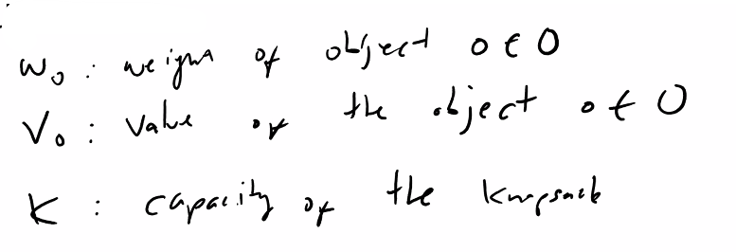

<- each object assigned a value

<- weight of the objects

<- Only so much space in the bag

**Variables**

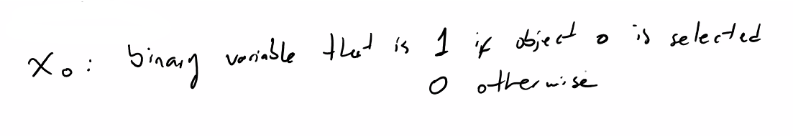

**Objective Function**

Max

**Constraints**

weight

capacity

weight

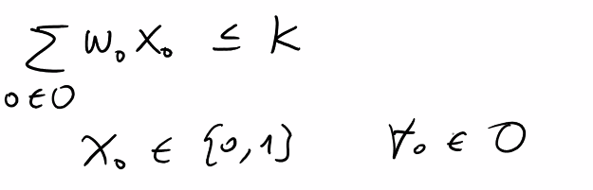

Objects are discrete (no fractions, integers)

*This is mixed-integer linear programming (MILP)*

(2)

(1)

**Integer Programming**

**Example:**

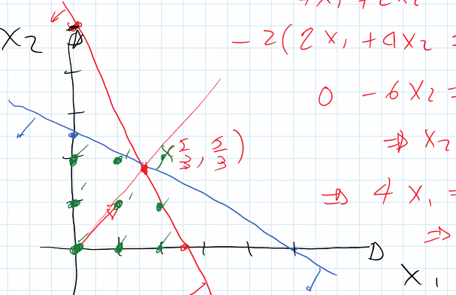

**Green = feasible as integers**

**Red and blue are feasible if continuous**

**How to get to optimal as integer?: *Branch and Bound***

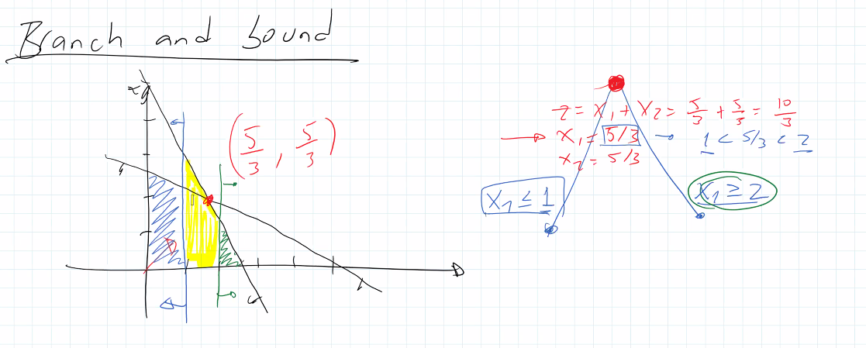

Blue and green regions are feasible, which are the floor and ceiling of the fraction 5/3

Yellow not feasible

* Use the new bounds from the regions as a new constraints.
* See what the value of the touching constraint is and compare. Choose the best and that is optimal.

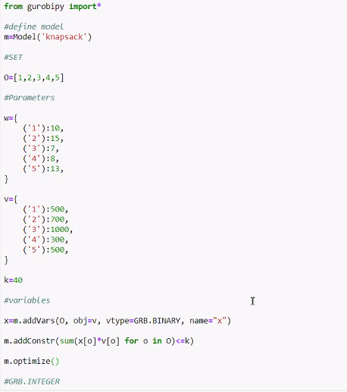

READ FROM EXCEL

**Using While Loop:**

**Finally, Optimize Model:**

